LAB221 Assignment | Type: | Short Assignment
 | Code: | J2.S.P0006
 | LOC: | 66
 | Slot(s): | 1

Title
Working with JList, JCombobox and images
Background Context
In java, you can use JLabel component to display an image inside. An image sometime is important especially when it comes to management problem, like a contact list or product list. This assignment will guide you and show you how to display an image inside a frame.
Program Specifications
Create an application using java swing to create a frame look like (1) and (2)
- ListDemo.java
- ComboboxDemo.java

Function details:
- Display the GUI like figure (1) and (2)
- When users select an item that is also the name of an animal, display corresponding picture of selected animal.

Expectation of User interface:

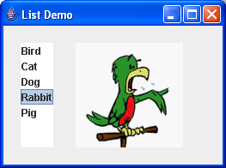(1)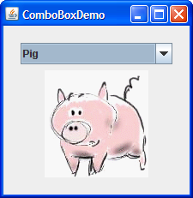 (2)
Guidelines

